**GENERAL PRESIDENCY**

**UNITED SOCIALIST REPUBLICS**

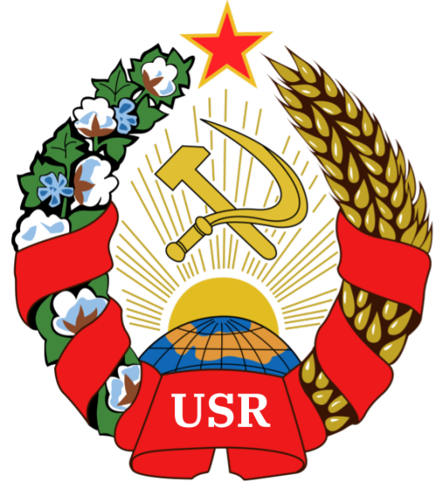

**GENERAL REFORM OF THE UNITED SOCIALIST REPUBLICS**

**Author:** Comrade GENERAL PRESIDENT TIZIAN ARUNA

**Sponsored by:** The Almendrian AR and the Communist Party of the United Socialist Republics

Hereby releases this document to the public.

---

**Article One:**

All government officials are hereby dismissed, except the ones affected by Article 2 or Article 3.

**Article Two:**

The following Effective Officials are not dismissed and shall suffer no changes due to this bill.

* General Secretary Autumn Gray
* Speaker Terry McKeen III
* President Johann Kummel
* General President Tizian Aruna

**Article Three:**

All other officials have a three (3) day grace period to either

* Gain an amount equivalent to 10 (ten) Socialist Credits for the U.S.R, which shall be paid in any currency or other medium of exchange.
* Gain 3 new Autonomous Republics and incorporate them.
* Invite 15 members to the United Socialist Republic’s digital platforms.

**Article Four:**

All Autonomous Republics are to be categorized through a census in one of the three following categories

1. Core Republic

* CRs shall be ARs in full adherence with the [Framework](https://docs.google.com/document/u/3/d/1f7TW1IBgtP_1JrF0f85LipJ-HfNWCbphcCmCfzN-UNI/edit) and the [Treaty of Declaration of the U.S.R](https://docs.google.com/document/d/1S4DzTfhO9nucFmvHbE7qrON4LkDAC4MwuCYWn47vanQ/edit)
* CRs have a [MyUSR](https://myusr.ml) dedicated page, and their currency may be traded on MyUSR
* CRs must have an [AlmChat](http://chat.almchat.ml) space.

1. Federated Republics

* FRs shall be ARs in full adherence with the [AR-Framework](https://docs.google.com/document/d/1f7TW1IBgtP_1JrF0f85LipJ-HfNWCbphcCmCfzN-UNI/edit).

1. Confederate Republics

* CRs shall have signed either the [AR-Framework](https://docs.google.com/document/d/1f7TW1IBgtP_1JrF0f85LipJ-HfNWCbphcCmCfzN-UNI/edit) or the [Treaty of Declaration of the U.S.R](https://docs.google.com/document/d/1S4DzTfhO9nucFmvHbE7qrON4LkDAC4MwuCYWn47vanQ/edit)

All ARs which do not fall into these categories shall be reduced to the following 2 statuses.

1. Incorporated Territory

* ITs are territories whose’s providence is known and ultimate control (platform ownership) is in the hands of the USR Government.

1. Unincorporated Territory

* UTs are territories where the USR exercises no control over.

A census shall be done to categorize these territories and ARs.  
  
**Article Five:**

All Unincorporated Territories shall hold votes of abandonment, if positive, these shall be abandoned and no longer form a part of the U.S.R.  
If negative, the Territories shall remain UTs but work shall begin to let them fulfill the requisites for IT and later on ARs.

**Article Six:**  
All new ARs must fulfill the conditions for becoming a Core Republic before incorporation. They must also have a minimum of 20 citizens, a currency that either is or can be ported to digitality, and a [MyUSR](https://myusr.ml) space.

**Article Seven:**  
FRs and CRs shall be examined, reformed, and turned into Core Republics. Leaderless FRs and CRs shall be appointed a leader, who will fulfill the task of becoming a Core Republic within 30 days.

**Article Eight:**  
All citizens shall make a [MyUSR](https://myusr.ml) account. Citizens that do not shall be marked as having abandoned citizenship, but shall still legally hold it, albeit their duties and rights are null.

**Article Nine:**  
The Red Congress shall be temporarily suspended, and the National Assembly takes on all of it’s duties.  
  
**Article Ten:**Rules on USR-managed Discord servers shall prohibit anti-USR ideologies and promote and establish seriousness, professionality and decorum.

**Article Eleven:**  
The office of Accountant-General shall be established. Taxes shall be levied upon all citizens, and all state profits and losses shall be recorded in Monthly Statements.

**Article Twelve:**

All officials, with no exceptions, shall provide weekly reports of their work on Sundays.  
If the work is not sufficient after 2 reports, they must be fired and removed from their position.

**SIGNED:**

**General President Tizian Aruna**



**NATIONAL SEAL**